**ACCOMODATION**

The Hotels in Catania are located within walking distance to the Monastero dei Benedettini:

* Best Western Hotel Mediterraneo

86 €

Hotel a 3 stelle

Via Dottor Consoli, 27, 95124 Catania CT•095 325330

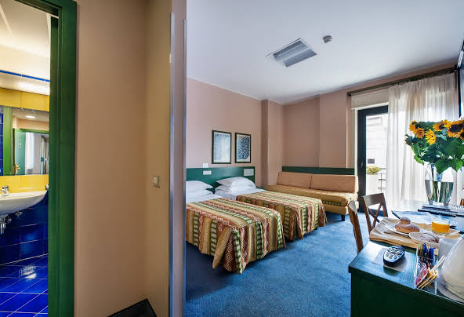

* Manganelli Palace

91 €

Hotel a 3 stelle

Via Recalcaccia, 2, 95131 Catania CT•095 715 1842

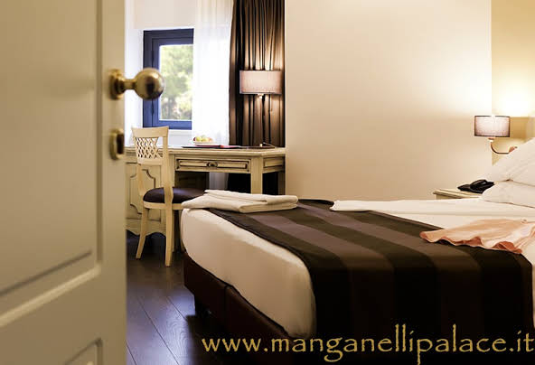

* Liberty Hotel

268 €

Hotel a 4 stelle

Via S. Vito, 40, 95124 Catania CT•095 311651

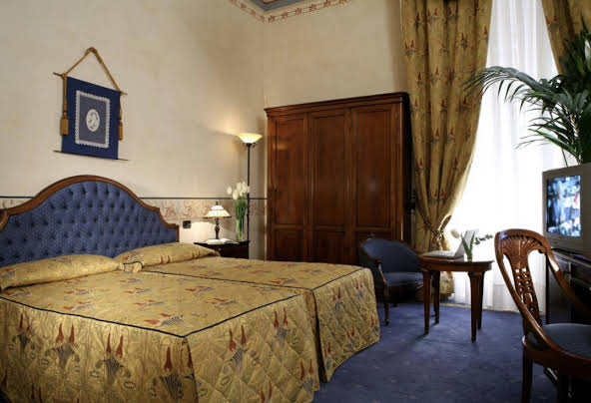

* Palace Catania | UNA Esperienze

188 €

Hotel a 4 stelle

Via Etnea, 218, 95131 Catania CT•095 250 5111

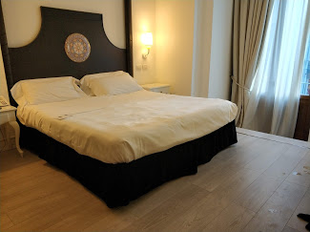

* Il Principe Hotel

154 €

Hotel a 4 stelle

24, Via Alessi, 95124 Catania CT•095 250 0345

